Samuel Raumin

Dr. Mei Klein

ECE 1310 – 03

February 3, 2020

Homework 2 Question 2.16

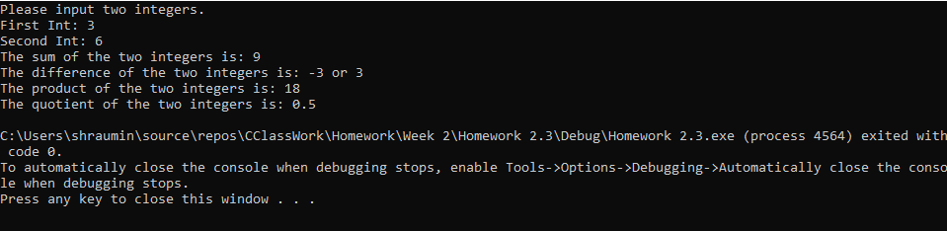

#include <iostream>

using namespace std;

int main(){

double x, y;

cout << "Please input two integers.\n";

cout << "First Int: ";

cin >> x;

cout << "Second Int: ";

cin >> y;

cout << "The sum of the two integers is: " << (x + y) << ("\n");

cout << "The difference of the two integers is: " << (x - y) << " or " << (y - x) << ("\n");

cout << "The product of the two integers is: " << (x \* y) << ("\n");

cout << "The quotient of the two integers is: " << (x / y) << ("\n");

}